**Testing**

**BlackBox Testing - Search Controller Class**

**Equivalence Class and Boundary Values**

The class takes in 1 input from the user:

1. The input is a String and must match the address of the property listing

| **Parameter** | **Equivalence Class (EC)** | **Boundary Value** |
| --- | --- | --- |
| Search String Entered | Valid EC:   * Substring of a property listing address   Invalid EC:   * Any phrase that does not fall under the listed subset above | Not applicable as there is no numerical range of values |

In the case of FlatFinderSG, we have chosen the Search feature to conduct Black Box Testing due the wide range of possible user inputs in the search bar. FlatFinderSG’s Filter function is highly controlled due to the use of choice chips.

**Expected Results**

**Valid Input**

| **Test Case ID** | **String Input** | **Substring of some Property Address** | **Expected Output** | **Actual Output** | **Result** |
| --- | --- | --- | --- | --- | --- |
| BB1.1.1 | “Blk 123A Rivervale Drive” | True | List of property listings with address “Blk 123A Rivervale Drive” | List of property listings with address “Blk 123A Rivervale Drive” | Passed |
| BB1.1.2 | “123A” | True | List of property listings with address “Blk 123A Rivervale Drive” | List of property listings with address “Blk 123A Rivervale Drive” | Passed |
| BB1.1.3 | “Blk 121 Hougang Ave 1” | True | List of property listings with address “Blk Hougang Ave 1” | List of property listings with address “Blk Hougang Ave 1” | Passed |
| BB1.1.4 | “121” | True | List of property listings with address “Blk Hougang Ave 1” | List of property listings with address “Blk Hougang Ave 1” | Passed |
| BB1.1.5 | “Blk 333A Senja Drive” | True | List of property listings with address “Blk 333A Senja Drive” | List of property listings with address “Blk 333A Senja Drive” | Passed |
| BB1.1.6 | “333A” | True | List of property listings with address “Blk 333A Senja Drive” | List of property listings with address “Blk 333A Senja Drive” | Passed |
| BB1.1.7 | “Blk” | True | List of property listings with the string “Blk” so “Blk 123A Rivervale Drive”, “Blk 121 Hougang Ave 1” and “Blk 333A Senja Drive” | List of property listings with the string “Blk” so “Blk 123A Rivervale Drive”, “Blk 121 Hougang Ave 1” and “Blk 333A Senja Drive” | Passed |
| BB1.1.8 | “Drive” | True | List of property listings with the string “Drive” so “Blk 123A Rivervale Drive” and “Blk 333A Senja Drive” | List of property listings with the string “Drive” so “Blk 123A Rivervale Drive” and “Blk 333A Senja Drive” | Passed |
| BB1.1.9 | “3A” | True | List of property listings with the string “A” so “Blk 123A Rivervale Drive” and “Blk 333A Senja Drive” | List of property listings with the string “A” so “Blk 123A Rivervale Drive” and “Blk 333A Senja Drive” | Passed |

**Invalid Input**

| **Test Case ID** | **String Input** | **Substring of some Property Address** | **Expected Output** | **Actual Output** | **Result** |
| --- | --- | --- | --- | --- | --- |
| BB1.2.1 | “SC2006” | False | No Results Found | No Results Found | Passed |
| BB1.2.2 | “Software” | False | No Results Found | No Results Found | Passed |
| BB1.2.3 | “000000” | False | No Results Found | No Results Found | Passed |
| BB1.2.4 | “,./” | False | No Results Found | No Results Found | Passed |
| BB1.2.5 | “abcd” | False | No Results Found | No Results Found | Passed |

**WhiteBox Testing - getResaleData()**

getResaleData() is a method that is utilized in our compare page which retrieves the resale price data as well as calculates the average price from a filter list of resale data for comparison with property listing prices.

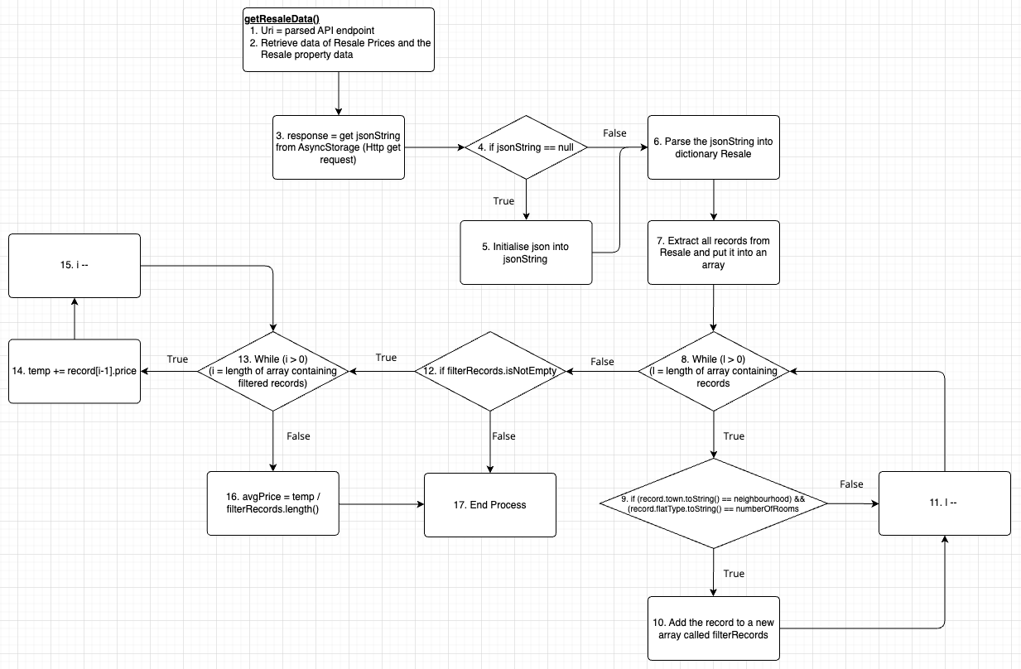

**Refer to getResaleData.png for a clearer image.**

It is important to note that the basis path 1-2,3,4,6,7,8,9,10,11,8,12,17 is **infeasible** as if it gets to 9, it suggests that some records have been extracted hence the length of the filtered array will never be zero and filterRecords.isNotEmpty cannot be False. Furthermore, the basis paths 1-2,3,4,6,7,8,12,13,16,17 and 1-2,3,4,5,7,8,9,11,8,12,13,16,17 are also **infeasible** as 12 only goes to 13 if filterRecords is NOT empty hence, the while loop will always run.

| **White Box Testing - getResaleData() Method** | | |
| --- | --- | --- |
| **Cyclomatic Complexity**  |edges| = 20  |nodes| = 16  CC = |edges| - |nodes| + 2 = 20 - 16 + 2 = 6  CC = |decisionpoint| + 1 = 5 + 1 = 6 | | |
| **Basis Paths** | | |
| #Path | Basis Path | Description of Basis Path Choice |
| 1 | 1-2,3,4,6,7,8,9,10,11,8,12,13,  14,15,13,16,17 | Baseline Path |
| 2 | 1-2,3,4,5,6,7,8,12,17 | Change first decision point from baseline path at node 4, testing 4 -> 5 edge |
| 3 | 1-2,3,4,6,7,8,9,11,8,12,17 | Change the four decision point from path #3 (The case where NO records are added to the filterRecords list meaning that length of filterRecords is 0) |
| **Test Cases** | | |
| #Path | Description of Test Case | Actual Values of Test Case |
| 1 | Baseline Path: Resale Data has been retrieved successfully and the records are filtered by the neighbourhood and number of rooms. | Filter by **town** = “BUKIT PANJANG” and **flatType** = “3 ROOM”. The prices of the filtered records are:  [  “price”: 311000,“price”: 332000,  “price”: 317000,“price”: 315000,  “price”: 318000,“price”: 315000,  “price”: 332000,“price”: 315000,  “price”: 338000,“price”: 338000,  “price”: 360000,“price”: 365000,  “price”: 338000,“price”: 350000,  “price”: 363000,“price”: 365000,  “price”: 370000,“price”: 350000,  “price”: 320000,“price”: 368000,  “price”: 400280,“price”: 375000,  “price”: 390000,“price”: 395000,  “price”: 390000,”price”: 410888,  “price”: 416500,”price”: 422000  ] |
| 2 | No data obtained using http get request | Display “Failed to load resale data”  records == Null  [ ] (No records in filteredRecords) |
| 3 | No data has been filtered out as there does not exist any records that fit the filter specifications. | Filter by **town** = “BUKIT PANJANG” and **flatType** = “3 ROOM”. The prices of filtered records are:  [ ] (No records fit the filter) |
| **Real Execution Paths** | | |
| 1 | 1-2,3,4,6,7,8,9,10,11,  8,9,10,11,8,9,10,11,8,9,10,11,8,9,10,11,8,9,10,11,8,9,10,11,8,9,10,11,8,9,10,11,8,9,10,11,8,9,10,11,8,9,10,11,8,9,10,11,8,9,10,11,8,9,10,11,8,9,10,11,8,9,10,11,8,9,10,11,8,9,10,11,8,9,10,11,8,9,10,11,8,9,10,11,8,9,10,11,8,9,10,11,8,9,10,11,8,9,10,11,8,9,10,11,8,9,10,11,8,12,13,  14,15,13,16,17 | [  “price”: 311000,“price”: 332000,  “price”: 317000,“price”: 315000,  “price”: 318000,“price”: 315000,  “price”: 332000,“price”: 315000,  “price”: 338000,“price”: 338000,  “price”: 360000,“price”: 365000,  “price”: 338000,“price”: 350000,  “price”: 363000,“price”: 365000,  “price”: 370000,“price”: 350000,  “price”: 320000,“price”: 368000,  “price”: 400280,“price”: 375000,  “price”: 390000,“price”: 395000,  “price”: 390000,”price”: 410888,  “price”: 416500,”price”: 422000  ] |
| 2 | 1-2,3,4,5,6,7,8,12,17 | “Failed to load Resale data”  [ ] |
| 3 | 1-2,3,4,6,7,8,9,11,8,12,17 | [ ] |

**WhiteBox Testing - grantCalculator()**

grantCalculator() is a method utilized in our individual property page that calculates the amount of grant applicants are eligible for based on their type of application, monthly household income, citizenship status, age, and whether they are first-time applicants. Note that fields retrieved are mandatory fields that applicants have to fill in when registering for an account. Hence, the fields will not be empty; values will not be Null.

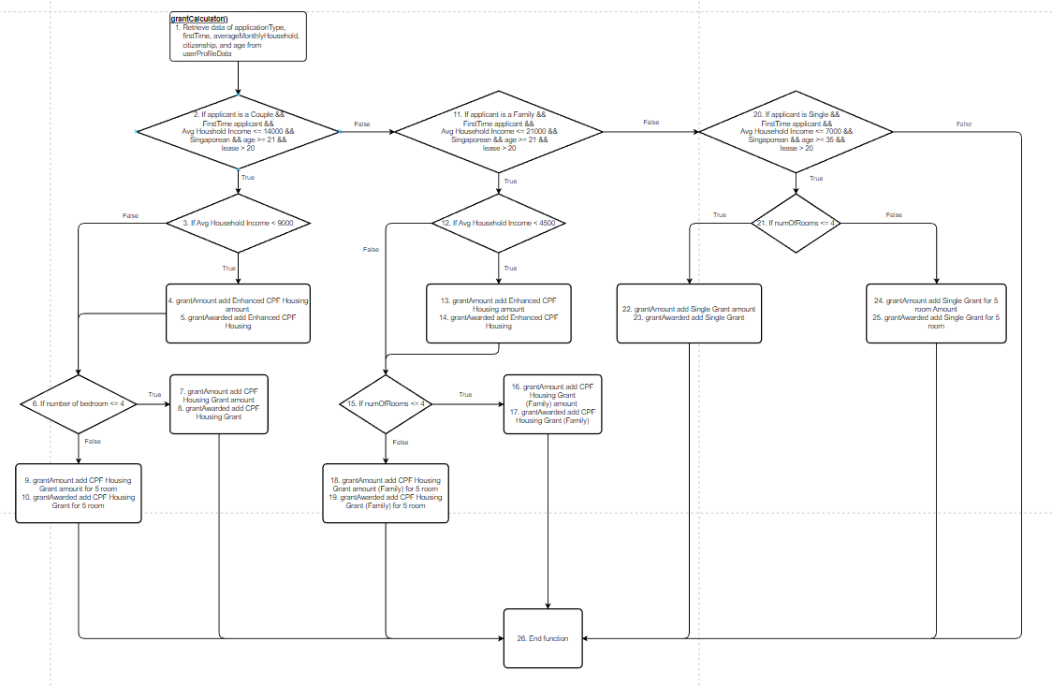

**Refer to grantCalculator().png for a clearer image.**

| **White Box Testing - grantCalculator() Method** | | |
| --- | --- | --- |
| **Cyclomatic Complexity**  |edges| = 25  |nodes| = 18  CC = |edges| - |nodes| + 2 = 25 - 18 + 2 = 9  CC = |decisionpoint| + 1 = 8 + 1 = 9 | | |
| **Basis Paths** | | |
| #Path | Basis Path | Description of Basis Path Choice |
| 1 | 1,2,3,4-5,6,9-10,26 | Baseline path 1 |
| 2 | 1,2,3,6,9-10,26 | Change second decision point from baseline path 1 at node 3, testing 3 -> 6 edge |
| 3 | 1,2,3,4-5,6,7-8,26 | Change third decision point from baseline path 1 at node 6, testing 6 -> 7-8 edge |
| 4 | 1,2,11,12,15,18-19,26 | Baseline path 2 |
| 5 | 1,2,11,12,13-14,15,18-19,26 | Change third decision point from baseline path 2 at node 12, testing 12 -> 13-14 edge |
| 6 | 1,2,11,12,15,16-17,26 | Change fourth decision point from baseline path 2 at node 15, testing 15 -> 16-17 edge |
| 7 | 1,2,11,20,21,22-23,26 | Baseline path 3 |
| 8 | 1,2,11,20,21,24-25,26 | Change fourth decision point from baseline path 3 at node 21, testing 21 -> 24-25 edge |
| 9 | 1,2,11,20,26 | Change third decision point from baseline path 3 at node 20, testing 20 -> 26 edge |
| **Test Cases** | | |
| #Path | Description of Test Case | Actual Values of Test Case |
| 1 | Applicant is a couple, first time applicant, has average household income of less than 9000 dollars, and is applying for an apartment with 5 rooms. Leftover lease of the apartment is more than 20 years. | applicationType = “Couple”, firstTime = “True”, averageMonthlyHousehold = “7000”, citizenship = “Singaporean”, age = “25”, lease = “45”  numOfBedroom = “5”  grantAmount:  [Enhanced CPF Housing Amount, CPF Housing Grant amount for 5 room]  grantAwarded:  [Enhanced CPF Housing, CPF Housing Grant for 5 room] |
| 2 | Applicant is a couple, first time applicant, has average household income of more than 9000 dollars, and is applying for an apartment with 5 rooms. Leftover lease of the apartment is more than 20 years. | applicationType = “Couple”, firstTime = “True”, averageMonthlyHousehold = “10000”, citizenship = “Singaporean”, age = “25”, lease = “45”  numOfBedroom = “5”  grantAmount:  [CPF Housing Grant amount for 5 room]  grantAwarded:  [CPF Housing Grant for 5 room] |
| 3 | Applicant is a couple, first time applicant, has average household income of less than 9000 dollars, and is applying for an apartment with less than 5 rooms. Leftover lease of the apartment is more than 20 years. | applicationType = “Couple”, firstTime = “True”, averageMonthlyHousehold = “7000”, citizenship = “Singaporean”, age = “25”, lease = “45”  numOfBedroom = “4”  grantAmount:  [Enhanced CPF Housing Amount, CPF Housing Grant amount]  grantAwarded:  [Enhanced CPF Housing, CPF Housing Grant] |
| 4 | Applicant is a family, first time applicant, has average household income of more than 4500 dollars, and is applying for an apartment with 5 rooms. Leftover lease of the apartment is more than 20 years. | applicationType = “Family”, firstTime = “True”, averageMonthlyHousehold = “9000”, citizenship = “Singaporean”, age = “25”, lease = “45”  numOfBedroom = “5”  grantAmount:  [CPF Housing Grant amount for 5 room (Family)]  grantAwarded:  [CPF Housing Grant for 5 room (Family)] |
| 5 | Applicant is a family, first time applicant, has average household income of less than 4500 dollars, and is applying for an apartment with 5 rooms. Leftover lease of the apartment is more than 20 years. | applicationType = “Family”, firstTime = “True”, averageMonthlyHousehold = “4000”, citizenship = “Singaporean”, age = “25”, lease = “45”  numOfBedroom = “5”  grantAmount:  [Enhanced CPF Housing Amount, CPF Housing Grant amount for 5 room (Family)]  grantAwarded:  [Enhanced CPF Housing, CPF Housing Grant for 5 room (Family)] |
| 6 | Applicant is a family, first time applicant, has average household income of more than 4500 dollars, and is applying for an apartment with 4 rooms. Leftover lease of the apartment is more than 20 years. | applicationType = “Family”, firstTime = “True”, averageMonthlyHousehold = “7000”, citizenship = “Singaporean”, age = “25”, lease = “45”  numOfBedroom = “4”  grantAmount:  [CPF Housing Grant amount (Family)]  grantAwarded:  [CPF Housing Grant (Family)] |
| 7 | Applicant is a single, first time applicant, has average household income of less than 7000 dollars, and is applying for an apartment with 4 rooms. Leftover lease of the apartment is more than 20 years. | applicationType = “Single”, firstTime = “True”, averageMonthlyHousehold = “6000”, citizenship = “Singaporean”, age = “25”, lease = “45”  numOfBedroom = “4”  grantAmount:  [Single Grant amount]  grantAwarded:  [Single Grant] |
| 8 | Applicant is a single, first time applicant, has average household income of less than 7000 dollars, and is applying for an apartment with 5 rooms. Leftover lease of the apartment is more than 20 years. | applicationType = “Single”, firstTime = “True”, averageMonthlyHousehold = “6000”, citizenship = “Singaporean”, age = “25”, lease = “45”  numOfBedroom = “5”  grantAmount:  [Single Grant amount for 5 room]  grantAwarded:  [Single Grant for 5 room] |
| 9 | Applicant is a single, first time applicant, has average household income of more than 7000 dollars, and is applying for an apartment with 5 rooms. Leftover lease of the apartment is more than 20 years. | applicationType = “Single”, firstTime = “True”, averageMonthlyHousehold = “10000”, citizenship = “Singaporean”, age = “30”, lease = “45”  numOfBedroom = “5”  grantAmount:  [ ] (No eligible grant)  grantAwarded:  [ ] (No eligible grant)  “You are not eligible for any grants.” |
| **Real Execution Paths** | | |
| 1 | 1,2,3,4-5,6,9-10,26 | grantAmount:  [Enhanced CPF Housing Amount, CPF Housing Grant amount for 5 room]  grantAwarded:  [Enhanced CPF Housing, CPF Housing Grant for 5 room] |
| 2 | 1,2,3,6,9-10,26 | grantAmount:  [CPF Housing Grant amount for 5 room]  grantAwarded:  [CPF Housing Grant for 5 room] |
| 3 | 1,2,3,4-5,6,7-8,26 | grantAmount:  [Enhanced CPF Housing Amount, CPF Housing Grant amount]  grantAwarded:  [Enhanced CPF Housing, CPF Housing Grant] |
| 4 | 1,2,11,12,15,18-19,26 | grantAmount:  [CPF Housing Grant amount for 5 room (Family)]  grantAwarded:  [CPF Housing Grant for 5 room (Family)] |
| 5 | 1,2,11,12,13-14,15,18-19,26 | grantAmount:  [Enhanced CPF Housing Amount, CPF Housing Grant amount for 5 room (Family)]  grantAwarded:  [Enhanced CPF Housing, CPF Housing Grant for 5 room (Family)] |
| 6 | 1,2,11,12,15,16-17,26 | grantAmount:  [CPF Housing Grant amount (Family)]  grantAwarded:  [CPF Housing Grant (Family)] |
| 7 | 1,2,11,20,21,22-23,26 | grantAmount:  [Single Grant amount]  grantAwarded:  [Single Grant] |
| 8 | 1,2,11,20,21,24-25,26 | grantAmount:  [Single Grant amount for 5 room]  grantAwarded:  [Single Grant for 5 room] |
| 9 | 1,2,11,20,26 | grantAmount:  [ ] (No eligible grant)  grantAwarded:  [ ] (No eligible grant)  “You are not eligible for any grants.” |